**Brooklyn torah gazette**

**For parshas vayigash 5780**

Volume 4, Issue 17 (Whole Number 169) 7 Teveth 5780/ January 4, 2019

**Printed L’illuy nishmas Nechama bas R’ Noach, a”h**

For a free subscription, please forward your request to [***keren18@juno.com***](mailto:keren18@juno.com)

*Reprinted from the November 22, 2019 edition of the Flatbush Jewish Journal.*

**How Should We React**

**To Those Who Rabidly**

**Oppose Our Torah Values?**

**By Daniel Keren**

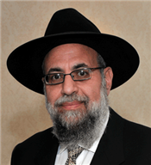

**Rabbi Aryeh Zev Ginzberg**

Last week in Flatbush a special December 25th legal day Yarchei Kallah Event was orchestrated by Hakhel, an organization dedicated to promoting a greater awareness of Torah-true values in our community. One of the highlighted speakers was Rabbi Aryeh Zev Ginzberg, Rav of the Chofetz Chaim Torah Center in Cedarhurst who lectured on the topic of “The Chareidi Chiloni Divide: Insights from Gedolei Hador – Past and Present, an Hashkafic and Halachic Analysis.”

Rabbi Ginzberg noted that there have always been divides among the Jewish people going back to the Eruv Rav (the Mixed Multitudes) in the Midbar after the exodus from Egypt. Each dor (generation) is different. Today Klal Yisroel is split in a horrible way. When we drop the achdus (unity), the goyim pick it up and run away with it to our detriment.

The secret of our strength is our unity. And when our achdus is disrupted, the danger facing us is unlike that facing any other nation. A Midrash teaches that it is better for non-Jews to attack us than for Klal Yisroel to be fighting each other.

When Pharaoh told Moshe Rabbeinu not to see his face again, he threatened that if he saw Moshe again he would punish him. Now at that time, the Egyptian army was the most powerful military force in the world, almost six times more potent than that of the next strongest nation on the planet.

But Pharaoh didn’t threaten Moshe with his awesome military might. Rather our Sages teach us that he threatened Moshe that he would have him physically dropped into the hands of Dason and Aviram, his arch enemies, an even worse punishment and torture that being attacked by non-Jewish enemies

Rabbi Ginsberg said that we all know about the coming dreadful war of Gog and Magog against Klal Yisroel whose armies would surround the holy city of Yerushalayim. There are many un-clarities about this conflict such as whether this will occur before or after the coming of Moshiach (the Jewish redeemer).

After the Second World War during which the Shoa (Holocaust) occurred, people often the only survivors of their families would come to Eretz Yisroel and go to Bnei Brak to ask the Chazon Ish if what the horrors they experienced in Europe had been a fulfillment of the dreadful prophecy regarding the threat of Gog and Magog. The Chazon Ish wasn’t able to answer them.

Perhaps the current terrible strife between the Chilonim (avidly anti-religious Jews) and the Chareidim (ultra-Orthodox Jews) in Israel today is the struggle of Gog and Magog.

Once Rav Moshe Feinstein met a prominent chareidi Jew from Yerushalayim and asked him about the situation in the holy city. At that time the mayor of Jerusalem was a chiloni who was doing everything he could to promote secular values and simultaneously harm the interests of the chareidi population. The chareidi Jew explained the difficulties caused by the mayor and added the curse Yemach Shemo (may his name be erased) that is used when referring to enemies of the Jewish nation.

This upset Rav Moshe very much and he said that Hakodesh Baruch Hu has a greater love for the worst Jewish rasha (sinner) than you or I have a love for the greatest tzadik.

Rabbi Ginsberg recalled a conversation that he had with Rabbi Simcha Wasserman, the son of the legendary Rabbi Elchonon Wasserman, hy”d. He asked Rabbi Simcha if he could relate something about his father that wasn’t generally known. The son recalled that the last thing his father ever told him was something that Rav Elchonon had heard the last time he was with his primary teacher – the Chofetz Chaim.

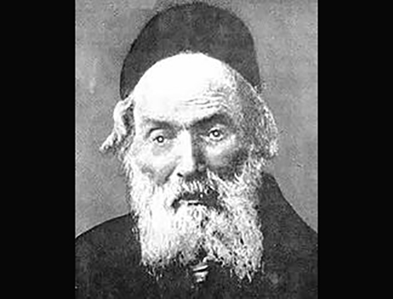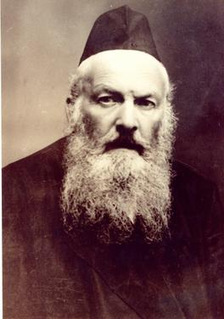

**The Chofetz Chaim and Rabbi Elchonon Wasserman**

A bochur (yeshiva student) had just informed the Chofetz Chaim that a newspaper had just published an article that said that 12 million people had died in the recent major war [that we know today as World War One.] This was a mind boggling figure at that time.

The Chofetz Chaim sighed and said that in just a few years there would be another major war [World War Two] that would make the recent war seem like child’s play and nobody would remember the recent war [World War One.]

The Chofetz Chaim told Rav Elchonon that the Third major world war was going to be Gog and Magog. And similar to the exodus from Egypt [where only 20% of all the Jews left their land of slavery alive. The other 80% who were not righteous were killed by Hashem during the plague of Hoshech (Darkness.]

Rav Elchonon told his son Rabbi Simcha that he should do his best to go out and try and reach out to those Jews who had become estranged from Yiddishkeit and try and bring them back to Torah so they could be among the 20% that would survive the terrible battle of Gog and Magog. Based on those words Rabbi Simcha devoted many years to educating Jewish boys in Los Angeles, then an almost complete spiritual wilderness.

Rabbi Ginsberg said the challenge for frum Jews today is to build your own emunah and conviction in Hashem and in that merit you will be worthy to be triumphant in the War of Gog and Magog and be zocheh (merit) to see the pnei (face) of Moshiach tzidkeinu.

We have to learn not just who to hate and how to hate, but more importantly how to with ahavas (love) work on bringing our chiloni foes back into the fold of Torah and the winning side of the Battle of Gog and Magog.

*Reprinted from the January 2, 2019 edition of the Jewish Connection.*

**Yehuda and Joseph’s Lesson Of Unity for the Jewish Nation**

**From the Talks of the Lubavitcher Rebbe**

**Rabbi Menachem Mendel Schneerson, Zt”l**

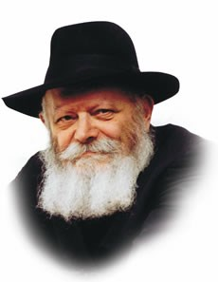

Nothing in the Torah is arbitrary, be it a word, a letter, a pause between sections or the lack of one.

Similarly, the name of each Torah portion reflects the contents and theme of the entire portion, and is not just a convenient way to distinguish between chapters.

(This helps to explain why certain portions are known by their initial word, whereas others receive their name from the second, third and subsequent words of the first verse.)

This principle is clearly demonstrated by the name of this week's Torah portion, Vayigash.

Our portion relates Judah's impassioned plea for the release of Benjamin, the reunion of Joseph with his brothers, the descent of Jacob and his sons to Egypt, and other occurrences.

A close look reveals that the common thread running through all these events is the theme of unity, summed up by the Hebrew word "Vayigash" -- "And he drew near."

"Vayigash" implies an actual physical meeting, one person approaching another to the point where they become one. According to the mystical Zohar, when Judah "drew near" to Joseph, it symbolized "the approach of one world to the other; the uniting of one with the other, till one entity was attained."

The theme of unity is also expressed in this week's haftora (which generally echoes the same theme as the Torah portion itself), which speaks of the unification of the divided Jewish people --the "kingdom of Judah" and the "kingdom of Joseph " -- that will take place in the Messianic Era. "And I will make them one nation in the land" the haftora reads, "And one king shall be king over them all."

"Vayigash" stands for the creation of unity in a place of discord and disharmony. Judah's offer to sacrifice himself on behalf of Benjamin demonstrated the unity and brotherhood that finally reigned between the sons of Jacob.

Joseph's revelation of his true identity likewise symbolized the unification of all twelve tribes -- forever granting their descendents the power to achieve true unity when Moshiach comes, speedily in our day.

The rest of Vayigash also expresses this theme, as the whole purpose of Jacob's descent into Egypt and his children's settlement there for hundreds of years was solely for the purpose of demonstrating G-d's unity in one of the lowliest places on earth. It was in Egypt, "the most corrupt among the nations," according to our Sages, that the Jewish people became a holy and unified nation.

Vayigash teaches us that unity is the essential foundation upon which Jewish life is built. But not only is unity the beginning, it is the objective of all our service as well, a goal that will be fully realized with the revelation of Moshiach.

*Reprinted from the Issue #345 of L’Chaim Weekly (Parashat Mikeitz 5755/1994)*

**Rabbi Berel Wein on**

**Parashas Vayigash**

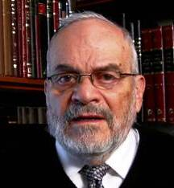

The dramatic moment that Joseph has dreamed of for decades has finally arrived. His dreams are to be fulfilled and he has achieved the ultimate triumph over his brothers who doubted him and his integrity. And at that moment, when he is at the zenith of his power, he breaks down and weeps. He is unable to control his emotions and his care for his brothers and his father and for the future generations of the Jewish people overwhelms him.

In a flash of reality, he realizes the consequences of his behavior and he pulls back from the abyss that would have destroyed the family of Jacob and prevented the creation of the people of Israel.

The rabbis of the Mishnah long ago told us that wisdom lies with those who can see the consequences of their actions and behavior in advance. Joseph clearly sees that he has pulled the rope as tightly as he is able to, and that any further action on his part would have dire consequences for the very future that he himself envisions.

If there will be a Jewish people and if he reconciles with his brothers, he knows that he will be remembered eternally as the righteous Joseph. If he exacts full revenge, justified as that may be in his mind, he knows that he dooms himself to being, at most, a footnote in the story of human civilization. His behavior towards his brothers, Judah and Benjamin, carries with it not only righteousness and altruism but a certain degree of self-interest and self-preservation. He realizes that only with greater unity of the tribes of Israel will he be remembered and truly justified.

When Joseph was tempted by the wife of Potiphar, we are told by *midrash* that he was able to overcome that desire because he realized that by succumbing, he would become an outcast amongst the tribes of Israel. And, he would not be represented on the holy breastplate of the high priest of Israel.

The rabbis warn us often that no matter what temptation or justification we may have for wanting to separate ourselves from the other tribes of Israel – many of whom we feel have failings or shortcomings or perhaps have even behaved incorrectly towards us – always brings sadness and personal disaster.

It is very tempting to go it alone and to not be burdened by the weaknesses and foibles of others. After all, we are aware that everyone but us is out of step! Nevertheless, we are constantly warned not to fall into that trap.

Joseph realizes that he cannot go it alone despite his temporal power and personal righteousness. And, in the moment of his greatest triumph, he seeks to unite and reconcile and create the necessary vehicle that will make the Jewish people eternal and eventually triumphant morally and physically.

*Reprinted from this week’s website of Rabbiwein.co*

**Thoughts that Count**

*And his brothers could not answer him, for they were terrified at his presence (literally "face")* (Gen. 45:3)

Joseph's face was identical to that of his father Jacob.

Yet when the brothers first met him in Egypt they did not recognize him, for Joseph kept his face covered with a mask. Upon revealing himself he uncovered his face, which frightened the brothers because he so closely resembled their father. *(Our Sages)*

*For how shall I go up to my father, and the lad is not with me* (Gen. 44:34)

Every Jew must ask himself: How can I go up to my Father in heaven "and the lad is not with me" -- without bringing the days of my youth? A person must be especially vigilant that he not squander away his younger years. *(Ma'ayana Shel Torah)*

*Reprinted from the Issue #345 of L’Chaim Weekly (Parashat Mikeitz 5755/1994)*

**The Outcome Depends**

**On Hashem**

**By Rabbi Eli J. Mansour**

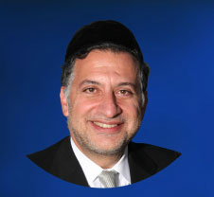

Parashat Vayigash begins with Yehuda’s impassioned plea to Yosef to allow his youngest brother, Binyamin, to return home to his father. Yosef, who ruled over Egypt – and whom the brothers did not recognize, as they had sold him as a slave when he was just seventeen – had ordered his servants to place his goblet in Binyamin’s bag to make him appear as a thief.

When the brothers were brought before Yosef, Yosef demanded that Binyamin remain in Egypt for his crime, while the other brothers return home. Yehuda, however, had assumed personal responsibility for Binyamin, and thus made an impassioned plea asking Yosef that he allow him – Yehuda –to remain instead of Binyamin.

Curiously, the vast majority of Yehuda’s speech is simply a review of the events told in last week’s Parasha. Yehuda reviews the story of how the brothers came to purchase grain, and Yosef accused them of spying and demanded that they bring Binyamin to prove their innocence.

Yosef, of course, was well aware of what happened, and did not need to be

reminded of the sequence of events. Why, then, did Yehuda find it necessary to present a lengthy review of the story?

One explanation that has been given is that Yehuda was actually speaking not to Yosef, but to G-d. The great Sadikim understand that even as they do the work that is needed to be done, he outcome depends solely on Hashem. When great Rabbis needed to advocate on behalf of the Jewish community before the gentile authorities, they applied themselves tirelessly to the task, but all the while they recognized that the results ultimately lie in Hashem’s hands.

Even as they appealed to the authorities, in their minds they were appealing to G-d. Yehuda, too, was speaking with Yosef, but in his mind he was speaking

with Hashem. And thus he reviewed the entire sequence of events as part of his pouring his heart out to G-d. When we speak to Hashem, we are, indeed, to express everything that is on our mind. Yehuda told everything about his situation not because Yosef needed to hear it, but because he was speaking primarily to Hashem, who wants to hear everything we are feeling and going through.

Rav Yitzchak Hutner (1906-1980), the famed Rosh Yeshiva of Yeshivat Chaim Berlin, once wrote a letter of encouragement to Rabbi Moshe Sherer, Chairman of Agudath Israel of America.

In the letter, he gave Rabbi Sherer three instructions. First, he told Rabbi Sherer that he must never become angry. Working in public service is bound to draw criticism, and one must ensure to retain his composure and not lose his temper in face of the pressure.

Secondly, Rav Hutner wrote, a public servant must never grow tired. He must work diligently regardless of what it is entailed. Thirdly, he wrote that Rabbi Sherer must never “aim to accomplish.” In other words, he must exert the necessary efforts, but always recognize that the outcome ultimately depends on Hashem. We should not set out to achieve with he mindset that the results depend on our efforts. We must make the effort, but while firmly believing that the outcome is determined by G-d, and does not depend on us.

Even as we “speak to Yosef,” our minds must be focused on speaking to Hashem.

*Reprinted from this week’s website of the Edmond J Safra Synagogue of Brooklyn website.*

**The Shmuz onParshas Vayigash**

# **By What Currency Do**

# **You Measure Success**

**By Rabbi Bentzion Shafier**

**Founder of TheShmuz.com**

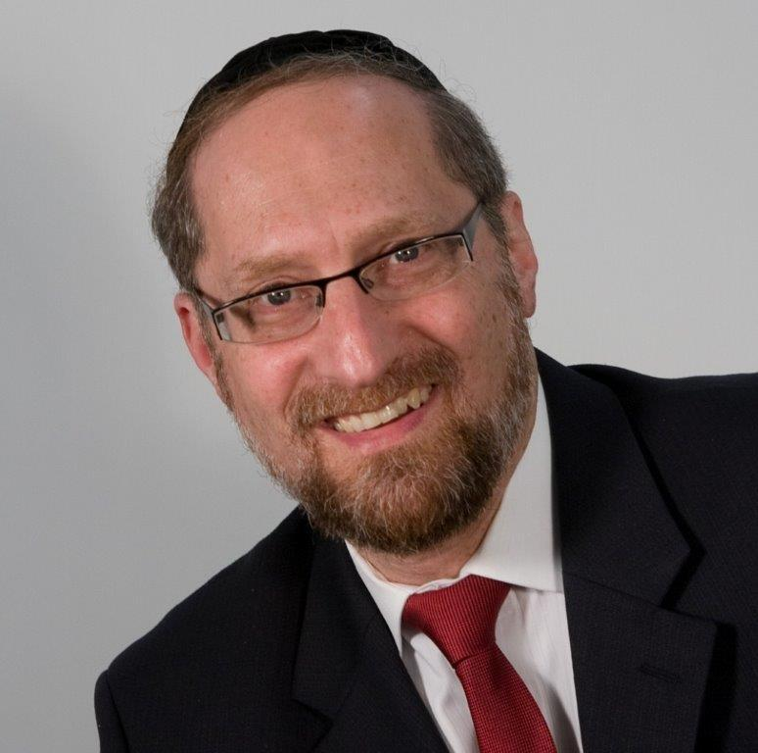

**By Rabbi Bentzion Shafier**

**Founder of TheShmuz.com**

“And they related to him all the words of Yosef that he had spoken to them, and he saw the wagons that Yosef had sent to transport him, then the spirit of their father Yaakov was revived.” — Bereishis 45: 27

For twenty-two years, Yaakov Avinu was in a state of mourning. His beloved son, the one who most closely followed in his ways, the one whom he envisioned as the leader of the next generation, had been taken from him — and the boy was still a youth.

For all those years, Yaakov was inconsolable. Now the brothers had come back with the news: “Yosef is still alive!” At first Yaakov could not believe it — it just couldn’t be. The brothers convinced him that it was true by showing him the wagons that Yosef had sent.

Rashi explains that the wagons were a code. The last sugyah (Torah topic) that Yosef had been learning with his father was eglah arufah, a calf that is killed for atonement. The Hebrew word egel, or calf, is similar to eglah, which means wagon. Yosef was using a play on words to refer back to the last topic that they discussed in their Torah studies. Once Yaakov saw the wagons, his mind was reminded of their last Torah discussion, and he knew that Yosef was alive. “No one else could have known this. It’s a clear sign that it’s Yosef. He is still alive!”

The problem with this Rashi is that it is difficult to imagine that Yosef would expect his father to vividly recall a conversation that they had had twenty-two years earlier. Even if Yosef had sent back a clear message, it would be difficult to imagine that Yaakov would remember a conversation that far back. But that isn’t what Yosef did. He sent the wagons as a cryptic hint. Why did Yosef assume that his father would recall their conversation from that? And how, in fact, did Yaakov make the connection?

The answer to this question lies in understanding the significance of certain events.

**Where were you when Kennedy died?**

Each generation has its defining moments. If you ask people who grew up in America in the 1960’s where they were when Kennedy was shot, many will be able to describe not only where they were standing when they heard the news, but even the details of the wallpaper of the room they were in.

In more recent times, if you ask someone, “Where were you on 9/11?” many people will vividly recall the exact part of the office they were standing in and who they were talking to when they heard about the Twin Towers going down. The same person who can’t remember what he had for breakfast this morning can clearly recall an event that happened years ago.

Certain events make an indelible impression upon us. Because of their significance and deep meaning, they become permanently etched into our minds. If we didn’t understand the implications of the moment, or if we didn’t view them as monumental, they would pass as just another one of the millions of events that we live through. But because we see these events as world-changing, as moments in history, they become part of us forever.

This seems to be the answer to this Rashi. The Avos (forefathers) lived with a very different value system than we do. To them, their words of Torah and novel understandings of it were earth-shattering. Because they understood the value of Torah and the change that it brought to them and to the world they lived in, they recognized learning as one of the most significant activities a human can ever engage in. And so, they lived those Torah discussions as epic moments in time.

For that reason, the sugyah that Yaakov and Yosef last discussed was ever-present in Yaakov’s mind. It wasn’t just another detail in his day; it was a defining moment. That is why Yosef took it as a given that one of the first things that his father would think about when recalling him was their last Torah discussion, and therefore, the play on words would not be distant from his mind.

**Changing currency**

One of the secrets to the Avos’ success was their clarity in values. They knew what was truly precious and how valuable it was. This is very different than what we typically experience. Most people we meet spend their lives with ever changing priorities; that which was so important at one stage becomes insignificant and irrelevant at another.

To a young boy growing up in America, sports are king. That’s what really counts in his world. But it doesn’t last. It is soon replaced by friends and being popular. As he matures, grades and what college he gets into become the measure of success. Within a short while, his career and making money are all that really matter.

This phase passes as well, and then he finds himself willing to trade away huge amounts of his wealth to build his reputation. As he nears retirement, his health and then his future nursing home become his primary concern. Throughout his existence, that which was precious and coveted at one point becomes devalued and traded away as new priorities take over.

The currency is constantly changing. And so, while at each stage of life he may have done well, in the totality of what he has accomplished, it may not be much. Since he lived with an ever-changing system of values, he likely has not come even close to achieving his potential.

This concept applies to all of us. When we are done our job here, we will leave this earth, and we will view things from a very different perspective. Our currency then will be profoundly different than it is now. The amount of money that we had, the honor that we received, and even our place in the community, just won’t matter to us. And we will then look back and realize that had we been focused on true values, we could have accomplished so much more and we could have become so much greater.

The Avos lived their lives with Olam HaBa (The World to Come) firmly in front of them. This clarity shaped the value system that motivated them in everything they did. We need to use them as a model so that we can learn to measure our accomplishments in a currency of eternal value.

*Reprinted from this week’s website on TheShmuz.com This is an excerpt from the*[*Shmuz on the Parsha book*](https://theshmuz.com/product/shmuz-on-the-parsha-book/)*.*

**Rav Avigdor Miller on**

**Music is a Motor for the Soul**

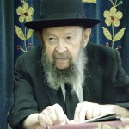

**QUESTION:** Some people say that there’s a certain power in music. Is that the case?

**ANSWER:** And the answer is that it's absolutely true. Although music per se, music by itself, is nothing at all, but if it's utilized for an ideal it becomes a powerful motor to help you arrive at your destination.

Now, suppose a man has a motor, an excellent motor. It turns over, let's say, so many and so many revolutions per second — it's performance is the smoothest there is.

Only that the motor doesn't have any belt that connects it to the wheels! So it accomplishes nothing! The spinning is useless; it's a complete waste of energy.

Music is only important if it's connected to an ideal. So if you do like Reb Yisroel Salanter did in his days when he started the study of *mussar* and he introduced the practice of saying: יסוד החסידות ושורש העבודה התמימה הוא שיתברר ויתאמת אצל האדם מה חובתו בעולמו מה חובתו בעולמו – The foundation of all piety and the root of the perfect service of Hashem is that one should recognize what is his duty here in this world, what is his duty here in this world; and then they started off singing to themselves, מה חובתו בעולמו, מה חובתו בעולמו – “What is my duty in this world? What is my duty in this world?”

That's what they did in the old *yeshivahs* at the instigation of Rebbe Yisroel Salanter. They learned *mussar* with a *niggun* – it was a sad, pensive, meditative *niggun*; and that was a way of using music and it began to enter your heart. מה חובתו בעולמו – “What is your duty in this world?” And they said it about fifteen times over and over again, and they said it with a tune. Then it pierces the shell of your heart, your hard-armored heart and it comes into the softness of the heart and you begin to think, “Actually, what is my duty in this world?”

So music, when it's utilized for *mussar*, when it's utilized for *avodas Hashem,* absolutely it's an excellent expedient. And that's why Dovid Hamelech when the spirit moved him and the *ruach hakodesh* came upon him and he said ברכי נפשי את  השם, so he took out his harp and the harp helped him begin to ascend on the wings of music to the heights of perfection of the soul.

But when music is used for, “Your eyes,” and “Your lips,” and your this and your that and how I miss you, and all the rest of the garbage, so the Kuzari says that means that the music which once was used for the service of Hakodosh Boruch Hu has now become the plaything of the maidservants and the boys in the street.

The Kuzari said that almost a thousand years ago. And it has deteriorated since then. Originally however, there's no question that music was intended to assist in the elevation of the spirit.

*Reprinted from the December 11, 2019 email of Toras Avigdor adapted from Tape #206.*

**More Thoughts that Count**

*And behold, your own eyes see, and the eyes of my brother Benjamin, that it is my mouth that speaks to you* (Gen. 45:12)

This was the first time that Joseph was speaking to his brothers in their native language. Prior to this time the brothers had spoken to him in Hebrew, but Joseph had answered in the Egyptian tongue.

The only time a person can recognize another through his voice is when he has previously heard him speak the same language. When a person speaks a different language, his accent is different and it is difficult to identify him. Because Joseph was now speaking Hebrew his brothers would be able to recognize him. *(Our Sages)*

*Reprinted from the Issue #345 of L’Chaim Weekly (Parashat Mikeitz 5755/1994)*

**Shtisel Complicated**

**My Judaism**

**By** [**Julia Malaga**](https://www.aish.com/authors/566014881.html)

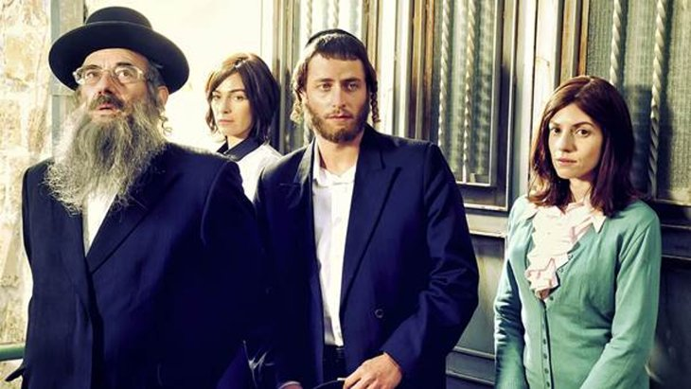

*Exposure to the closed, marginalized culture on the small screen made me realize how important it is to build bridges to the ultra-Orthodox.*

I succumbed to [*Shtisel*-mania](https://www.aish.com/sp/ph/Shtisel-on-Art-Spirituality-and-Forgiveness.html) this summer. I am a non-Orthodox convert to Judaism and am not considered a “real Jew” by the Haredi community portrayed in this series. I am fairly certain that Nuchem would refer to me as one of those “damn evil people.” Until *Shtisel*, my opinion of the Haredim was also not very flattering.

I co-chair a Jewish Federation committee that advocates for religious pluralism in Israel, that in many ways “fights” the ultra-Orthodox monopoly on religion in Israel. The ultra-Orthodox are a fast-growing and marginalized population. We ignore them at our peril. *Shtisel* helped me see that. It also complicated my Judaism.

I cried when Shulem painted over the woman’s hair in Akiva’s painting. I wanted to be indignant at him for his reaction to the painting, but I found myself feeling his pain. I understood why he couldn’t have possibly had a different reaction to it.

As a modern woman, I wanted to agree with Giti that Ruchami should not be married at 15. However, I found myself understanding that a divorce would permanently affect her prospects for a future “normal” life in her community. I found myself agreeing with the table of men discussing whether her marriage was valid, or if she should seek a divorce.

Most of all, I saw Giti as a strong woman, a feminist in her own way. She took the power from her husband by refusing to acknowledge his betrayal when he begged her for forgiveness. She understood the power of that forgiveness and later gave it. I wanted to hate Lippe, but I found myself sympathizing with his rebellion. I didn’t want to want Giti to forgive him, but I rejoiced when she did. Both Giti and Ruchami are strong women who understand their power in a culture that many assume leaves them powerless.

By opening a window into a closed, misunderstood world, Shtisel enriched my Judaism while complicating it. I wouldn’t want it any other way.

Akiva’s artistic talent is accepted by him as gift from G-d, while his community seems to see it a temptation to undermine his Judaism. He said it was a part of his soul and a way for him to share “memory” in a figurative way. But Haredi culture does not have much room for figurative interpretation, and this most sensitive character risked everything to be true to his nature. I rejoiced for him when he rejected his own promise to give up painting and despaired when Zvi Aryeh gave up an opportunity to pursue his own artistic dreams. I understood why each made an opposite decision within the same cultural context.

I believe we should be engaging members of this community in our shared society work. Increasing marginalization will only lead to a greater divisions between secular and religious Jews in Israel. I very much want to engage and learn and grow in partnership with this sector of Israeli society, perhaps finding opportunities to build bridges to the women within it.

After watching [*Shtisel*](https://www.aish.com/j/as/The-Shtisel-Phenomenon.html), I have changed as a Jewish woman. I won’t be covering my hair anytime soon or wearing unflattering, modest clothing, but I now kiss every mezuzah I see, and I have learned many new blessings for everyday miracles. By opening a window into a closed, misunderstood world, Shtisel enriched my Judaism while complicating it. I wouldn’t want it any other way.

*Reprinted from the December 9, 2019 website of Aish.com*

**World's Largest Book Club: 92,000 Who Read Entire Talmud to Celebrate at MetLife Stadium**

**By** [**Deena Yellin**](http://www.northjersey.com/staff/2647872001/deena-yellin/)

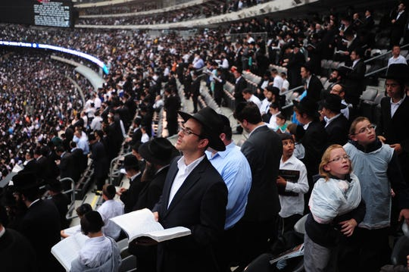

**More than 90,000 men and women gathered together at MetLife Stadium on Wednesday, August 1, 2012 to celebrate the completion of 7- 1/2 years of learning to the completion of the Talmud. The next celebration is on Jan. 1, 2020. *(Photo: Marko Georgiev, MARKO GEORGIEV/STAFF PHOTOGRAPHE)***

Organizers are billing it as the largest gathering MetLife Stadium has ever hosted.

But the throng of more than 92,000 men and women expected to pack the East Rutherford venue on Jan. 1 aren't gathering for a playoff game or New Year's gala: They will celebrate having read the entire Babylonian Talmud from cover to cover in an event called Siyum HaShas.

Learning the ancient, voluminous work of Jewish law and folklore is no simple feat: It takes participants 7½ years to complete all 2,711 pages.

Such a venture warrants a momentous celebration — in Hebrew, a siyum.

Isaac Perle of Lakewood, a clinical assistant professor at the University of Pennsylvania, who describes himself as a lifelong Giants fan, said that even if the Giants were to win the Super Bowl, it couldn't compare to the Siyum HaShas.

"This definitely tops it," Perle said.

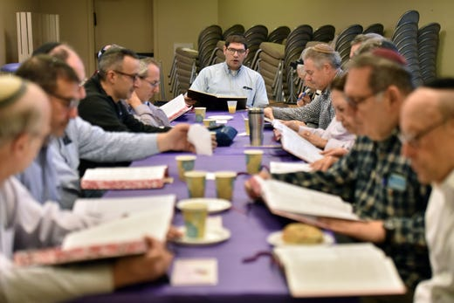

**Teaneck study group studies Talmud at Congregation Keter Torah**

The MetLife gathering will be the largest venue — organizers have erected seating and a large dais on the field — and an overflow crowd of 20,000 is expected at the Barclays Center in Brooklyn. Through satellite hookups, the event will be beamed to over 100 sites across the globe, including Boca Raton, Florida; Los Angeles; Scottsdale, Arizona; and across South America, Europe and Israel.

The large gatherings come amid an uptick in violent attacks on Jews in the greater New York area. On Saturday night, [a man with a knife attacked five](https://www.lohud.com/story/news/local/rockland/monsey/2019/12/29/monsey-stabbing-orange-county-man-thomas-grafton-charged-attempted-murder/2768801001/)[Hasidic](https://www.lohud.com/story/news/hudson/2019/12/12/jersey-city-shooting-our-complete-coverage-fatal-nj-shootout/4400861002/)[Jews at the home of a rabbi in Monsey, New York.](https://www.lohud.com/story/news/local/rockland/monsey/2019/12/29/monsey-stabbing-orange-county-man-thomas-grafton-charged-attempted-murder/2768801001/) On Dec. 10, [two Hasidic Jews and a clerk at a kosher grocery store were killed in Jersey City.](https://www.lohud.com/story/news/hudson/2019/12/12/jersey-city-shooting-our-complete-coverage-fatal-nj-shootout/4400861002/)

Siyum organizers — and public safety officials — say security will be tight at the event.

"There will be over 300 uniformed state police in the stadium, and that's just the visible ones," said Rabbi Yosef C. Golding, chief operating officer of the Siyum HaShas.

The East Rutherford stadium, Golding said, will be "the safest place to be on January 1st."

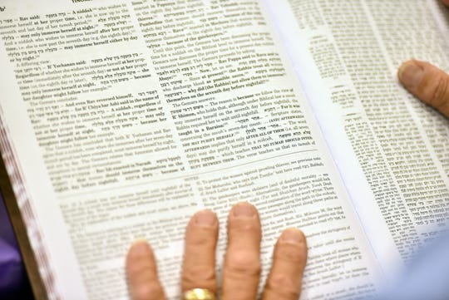

**A daf yomi group at Congregation Keter Torah studies a page of the Talmud on Sunday morning, December 29, 2019. For almost seven and a half years straight, Jews around the world have been reading the Talmud, cover to cover, a page at a time. *(Photo: AMY NEWMAN/NORTHJERSEY.COM)***

Golding said he's been working for months with more than 50 law enforcement agencies, including the New Jersey State Police, New Jersey Department of Homeland Security, New York Police Department and FBI to ensure safety during the celebration.

All told, more than 150,000 participants will be marking the 13th cycle of daf yomi, Hebrew for daily page, which refers to the worldwide study program of the Talmud, said officials at Agudath Israel, the Orthodox Jewish group that has sponsored the event since its inception 96 years ago.

In short, this is the world's largest and longest-running book club.

Participating creates a sense of unity among Jews around the world because everyone is literally on the same page every day, said Henry Frisch of Teaneck.

The retired English teacher has been learning daf yomi since 1993, which means he's completed the Talmud 3½ times, and has attended several Siyum HaShas events. "There's a camaraderie," he said.

Gail Licht, a retired attorney from Teaneck, attends the same study group as Frisch; it meets at Congregation Keter Torah in the township early each morning. "I have found groups in Florida and Jerusalem," she said, adding that she's even listened to a daf yomi app provided by El Al on a recent flight to Israel.

Part of the lure, she said, is the intellectual stimulation. "It's very similar to studying American law," she said.

The daf yomi program was established in 1923 by Rabbi Meir Shapiro of Poland, a Hasidic rabbi known as the Lubliner Rav whose aim was to increase unity among the Jewish people and bring laymen into Talmudic study.

Participation continues to grow. Wednesday's event will mark the 13th Siyum HaShas.

"I remember in 1982, when 5,000 people showed up and I thought that was a lot. Then in 1990, we held it at Madison Square Garden and 25,000 people came," said Rabbi Labish Becker, executive director of New York-based Agudath Israel. "The participation is across the Jewish spectrum. Everyone feels a part of it."

The previous siyum, in 2012, also held at MetLife Stadium, was a sold-out event that drew a crowd of 90,000.

Gov. Phil Murphy is among the VIPs expected to attend the event, which will feature singing, dancing and words of inspiration from rabbinic leaders. The celebration will last a few hours. And afterward, daf yomi participants will open the first page of the Talmud and begin all over again.

The Talmud is a compilation of wide-ranging rabbinic discussions of Jewish law, which guide every aspect of life from business ethics and real estate law to marriage and parenting advice.

Today, people from many walks of life are able to learn the complex work, in large part because of the proliferation of study groups and numerous translations of the text, which make it easier to understand.

Study of the ancient work has also had a growth spurt because of technological advances. Talmud apps, podcasts and e-mail groups have allowed people to access the lessons anywhere they go at any time of day. Several Facebook groups are devoted to daf yomi, including one exclusively for women and another for beginners. And at least one Twitter user, Rabbi Josh Yuter, who is formerly of New Jersey and now of Israel, tweets out daf yomi lessons daily.

There are daf yomi groups that meet in synagogues, in carpools, at Israeli army bases, and even on the New York subway and Long Island Rail Road.

For centuries, Talmud study was considered the domain of men. But in recent years, an increasing number of women have been diving into it, with more opportunities for women's Talmud study opening. Organizers of the siyum anticipate that around 30% of Wednesday's participants will be women.

Author Ilana Kurshan wrote eloquently about her experience digging into daf yomi in her novel "If All The Seas Were Ink" (St. Martin's Press: 2017). This year for the first time, a celebration for women around the world will be held in Jerusalem to mark their completion of the daf yomi.



***Photo from the last Siyum Hashas at MetLife Stadium on August 1, 2012.***

Perle, who began learning daf yomi in 1978 while a dental student at the University of Pennsylvania, found a rabbi with whom to learn daily at 6 a.m. "At the time, there weren't so many study groups like there are now," Perle said. Eventually, he moved on to Harvard, where he started his own daf yomi class. Thus far, he has completed shas five times. "Each time, I realize how little I know," he said.

Frisch said that although he has already completed the Talmud several times, he's not done. "This is something that really becomes a part of your life," he said. "I can't imagine stopping at this point."

*Deena Yellin covers religion for NorthJersey.com.*

*Reprinted from the December 30, 2019 website of NorthJersey.com*